Visa Helper Instructions

# Setup

There needs to be a file called **database.csv** in this folder. This database file is a special type of file called a **.csv** or **Comma Separated Value** file. Luckily, we can make this file using Microsoft Excel.

## Create Database File

1. Open up the spreadsheet with your missionaries’ information (we will need their name, email, and the password for the visa website). A screenshot of a computer

   Description automatically generated with medium confidence
2. Select the columns that contain the name, email, and password by holding down the **ctrl** key and left-clicking on the letter above each desired column. A screenshot of a computer

   Description automatically generated with medium confidence
3. Open a new spreadsheet by clicking **File**, then **New**, then double click on **Blank workbook**. A screenshot of a computer

   Description automatically generatedA screenshot of a computer

   Description automatically generated with medium confidence
4. Select the top-left cell (A1) and press **ctrl+v**

1. Now, there should be 3 columns of data in the new spreadsheet. **Column A** should be the name, **column B** should be the email, and **column C** should be the password. Make sure that they are in that order and that the first row is a header that says, “name”, “email”, and “password” respectively. A screenshot of a computer

   Description automatically generated with medium confidence
2. A screenshot of a computer

   Description automatically generatedA screenshot of a computer

   Description automatically generated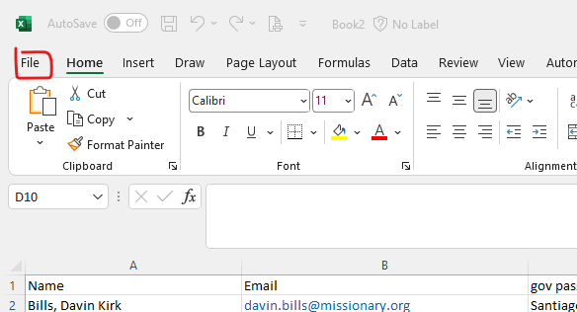Select **File**, **Save As**, **Browse**, and navigate to this folder (called **dist**).
3. Double click on **dist**, change the file name to **database**, and change the file type to **CSV (Comma delimited)**. Click **Save**.

## How To Use Visa Helper

1. Navigate to the folder called **dist.**
2. **Make sure the database excel file is not open in Excel.**
3. Right click on the file called **visahelper**.
4. Click **Run as administrator**.
5. Click **Yes** on the prompt that comes up.
6. A window will pop up and the program will execute. Once it finishes, it will tell you that you can close the window by pressing enter.
7. Open the new file in **dist** that appeared, called **changelog**. You can open it in whichever text editor you want. There, you’ll see a list of the emails and passwords of all of the missionaries that have had changes in the data on the website since you last ran a scan. Each list of emails and passwords is preceded with a timestamp of when the scan was run. The most recent scan is at the top, with the oldest at the bottom of the file.
8. There will also be a new folder called **logs** after you run the program at least one time. Don’t delete this folder, as it contains the data collected from previous scans.

## Contact Information

**Contact me with any questions:**

Email: justin.plane@missionary.org

Phone (until the end of July 2023): +56 9 9534 5915